Task 7: Clone Facebook page and perform desktop phishing.

We are using SET tool in Kali Linux for cloning of Facebook page because it is automated process.

And then using it to capture credentials like username and password.

First, we login in into the Kali Linux VM.

Then we have to check our IP address.

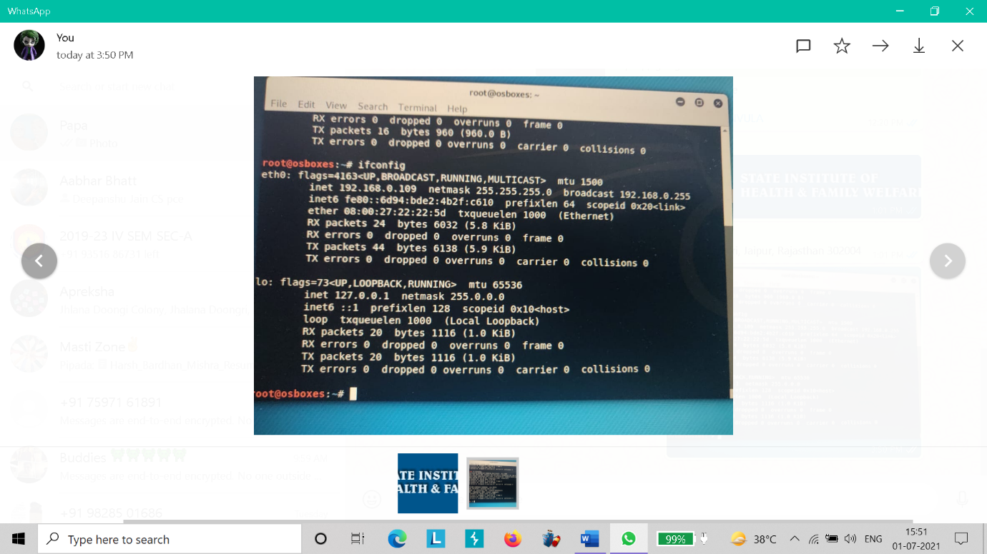

Then go to tools and select SET tool from social engineering tools.

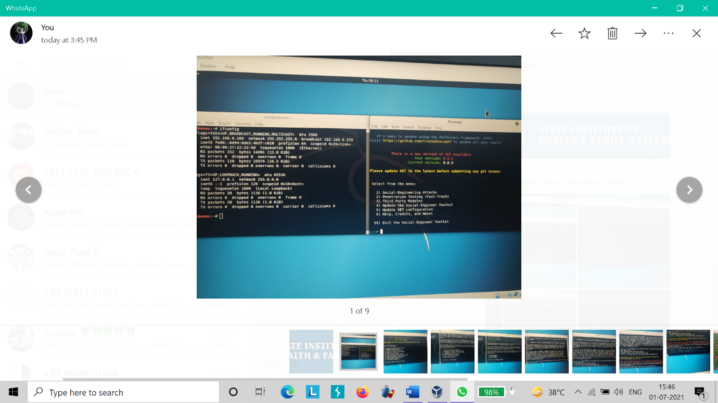

It will be like above image.

Now select 1 option for social engineering attack.

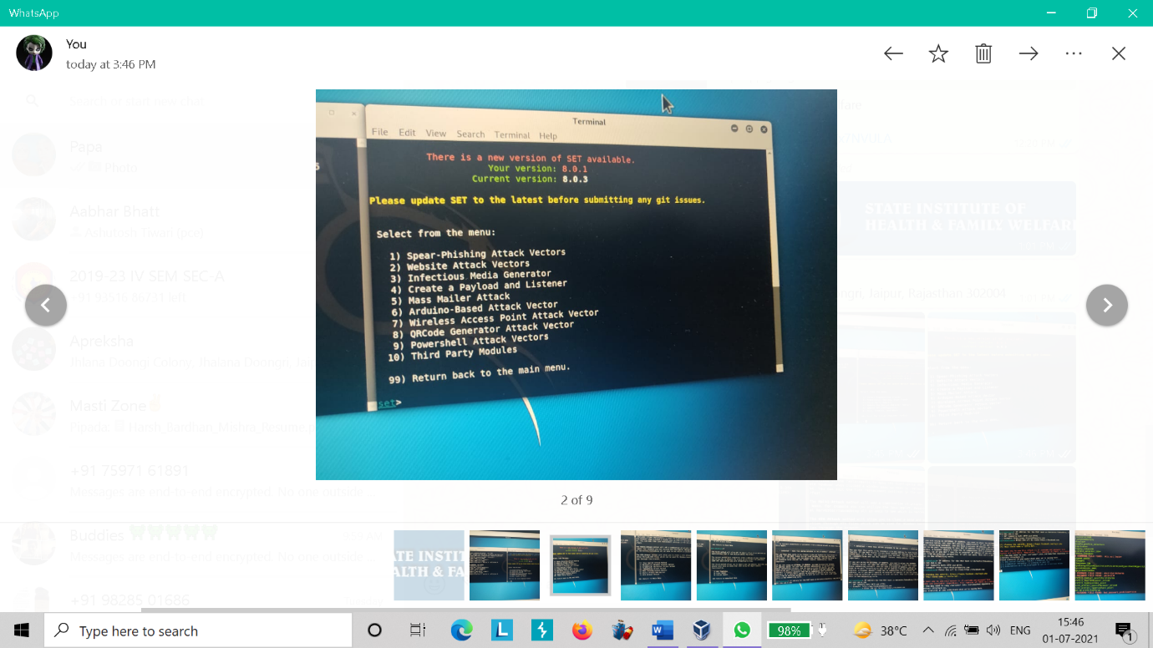

Now select 2 option for website attack.

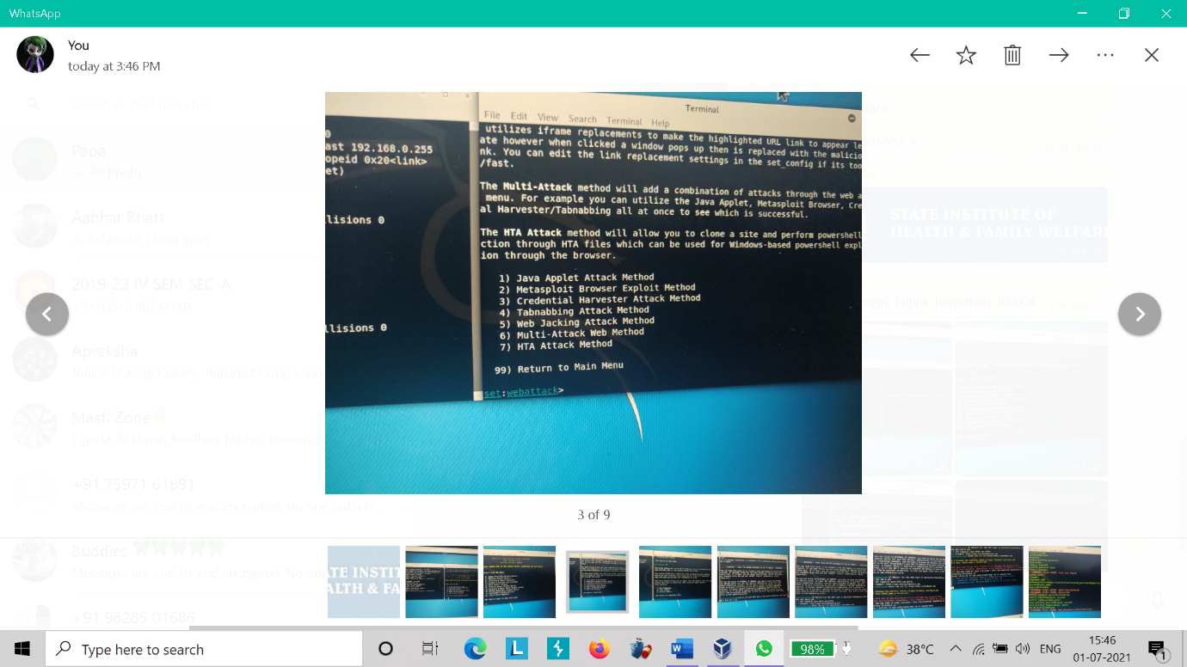

Now select option 3 for capture credentials.

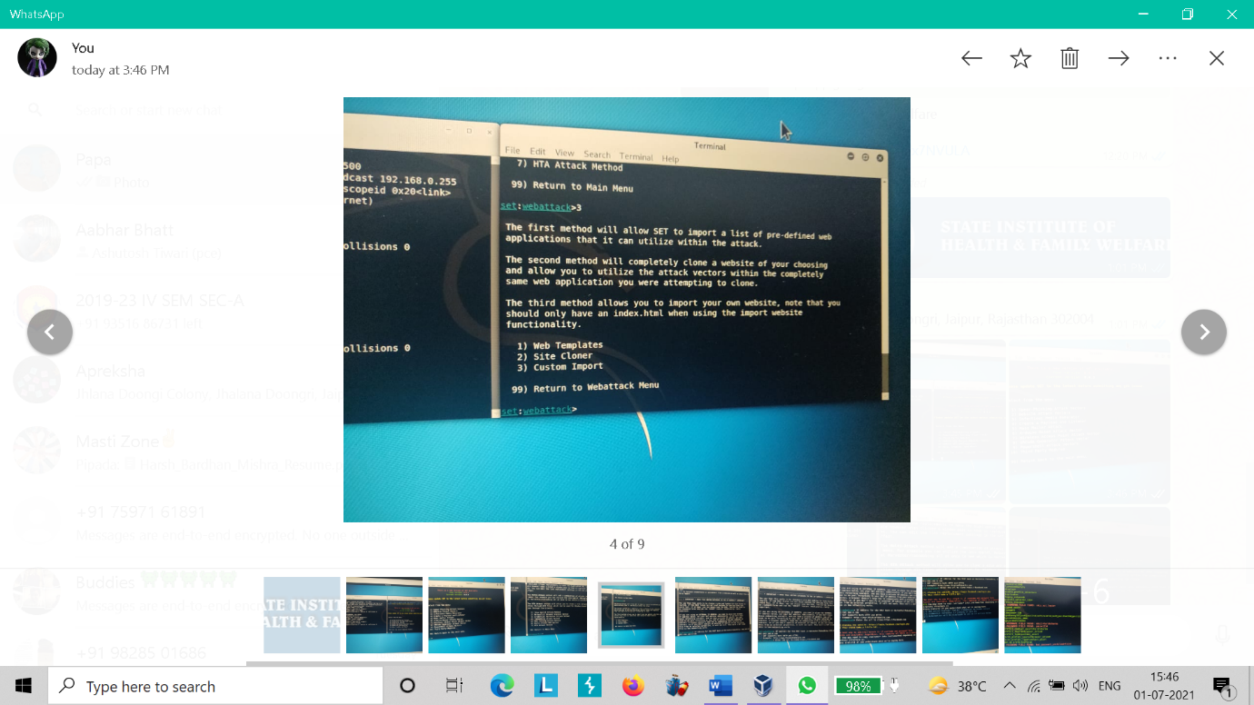

Now select 2 option for site cloner.

It will clone Facebook login page for us.

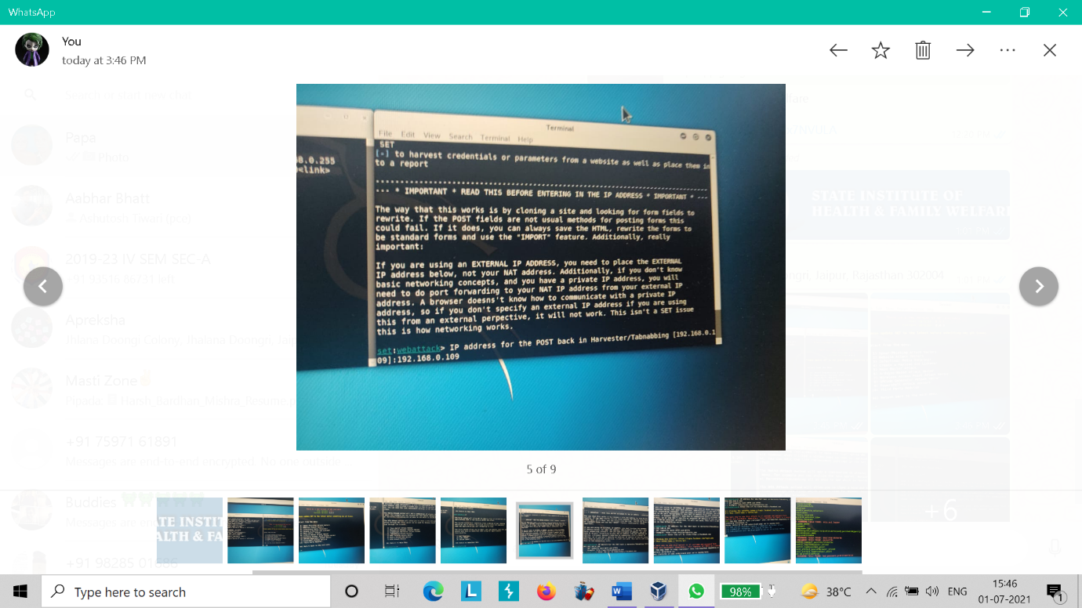

Now enter the IP address which you find out in first step (192.168.0.109).

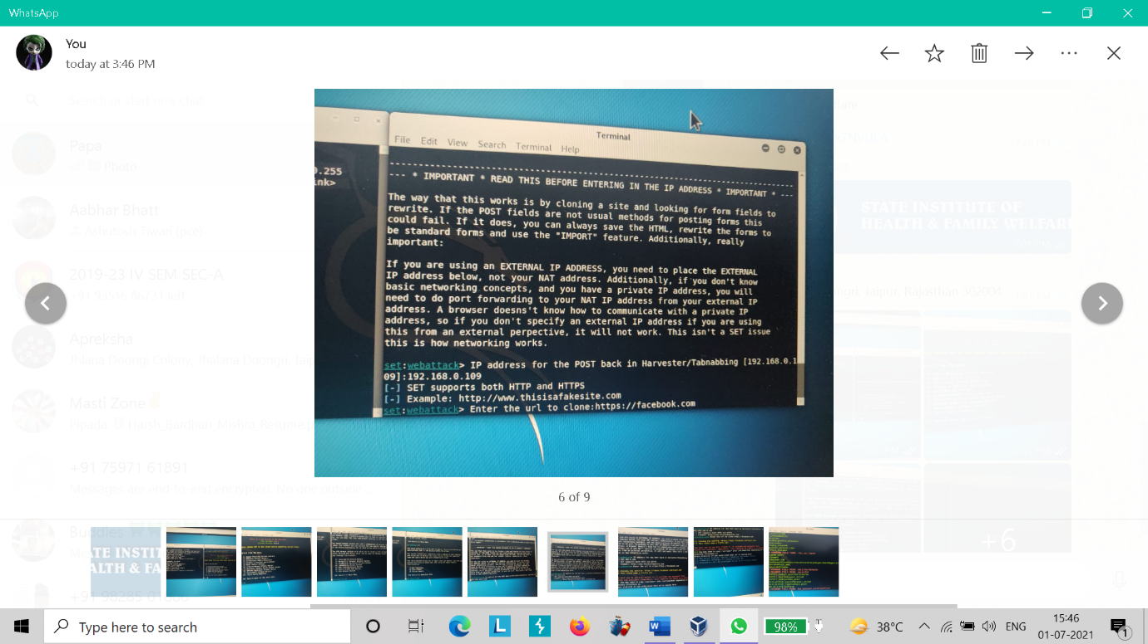

Now enter the official site URL to be cloned.

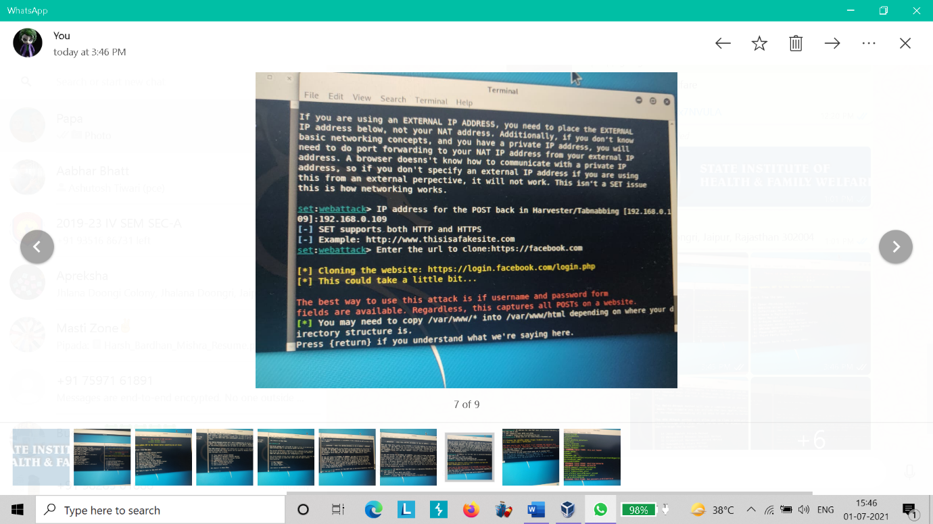

Hit Enter.

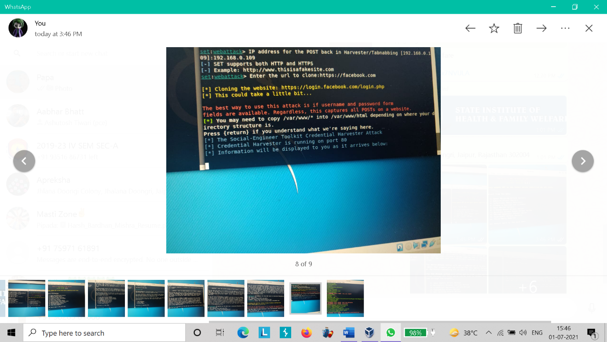

Now it has been started now every time someone enter its username and password is will be there in our tool.

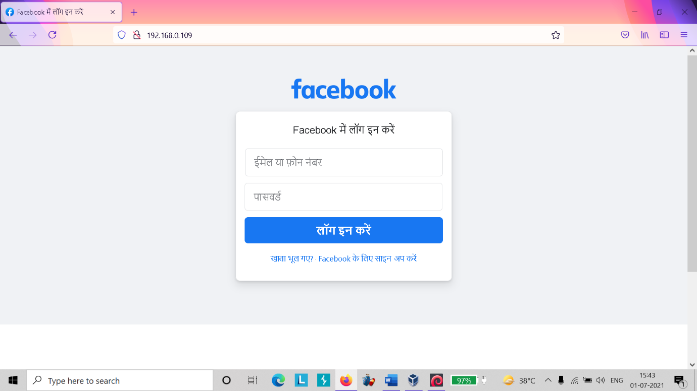

Here is the fake login page.

Now if victim entered-

Username: harshsharma

Password: 1234

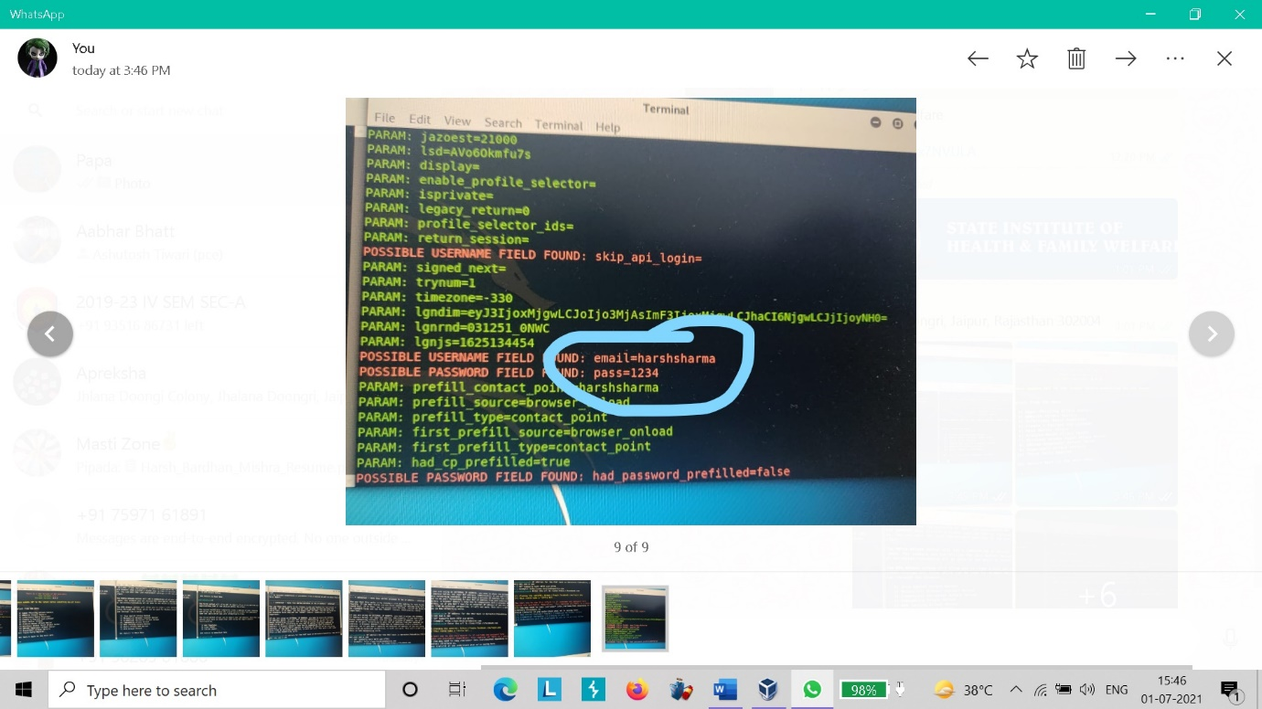

Here is the username and password.

And the victim will be redirected to the official site.

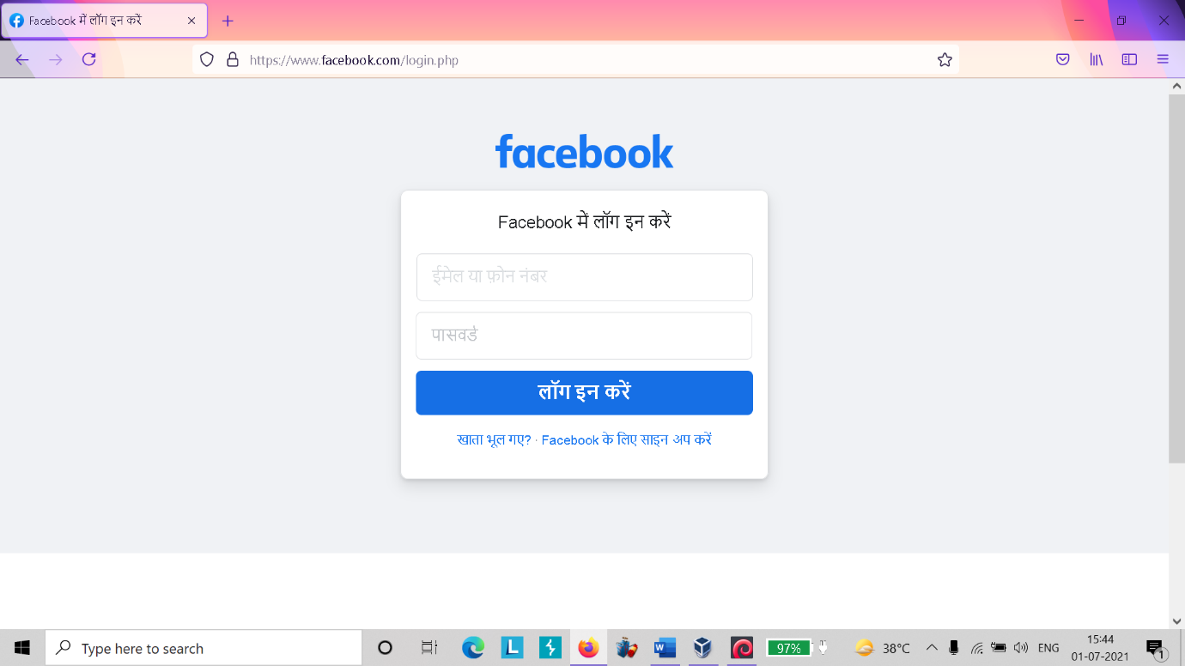

Now here are some ways by which we can prevent us from these types of attacks: -

* Avoid clicking on unknown URLs.
* Avoid clicking on unknown emails.
* Always see that is a secure website page like https.
* Do not enter essential information in suspicious pages.
* Protect your computer by security software.

Etc.